**PART I: INTRODUCTION**

**CHAPTER 1: ORGANISATION PROFIL**

* 1. **Company Details**

Company Name: Cloudester

Address: 304, Adalja Complex,

Nr Cash & Carry, Ellora Park,

Vadodara, Gujarat

Director: Mr. Ronak Shah

Contact number: 0265 - 3022440

At Cloudester, we take pride in representing our strong company culture. We have experienced technical professionals who have expertise in latest software technologies. We create simple to use and user friendly systems that help you to stay ahead of competition and up to date with latest technologies. We help you to automate your business processes making them more efficient and provide useful reports helping you to make better decisions. When you entitle us your project to get our services you can expect:

* Effectiveness in analyzing business requirements and we provide efficient solution.
* Timely delivery of project as agreed.
* Affordable prices.
* Experienced professionals working on your project.

Your business is safe and secure with our expert technicians. We provide our high level IT services with absolute confidence, protecting your important data and your business. We do concern for the clients’ confidential data and consider it our utmost responsibility to keep it safe and isolated. We are always ready to sign Non-disclosure agreement for the safety of client’s data. We offer and recommend annual maintenance contract (AMC) services for customer specific applications and products which are charged as per the services requested by the client.

We provide the various services at affordable prices. Our services include custom software development for various platforms like web, mobile and desktop. We are specialized in Microsoft based technologies along with android and ios platforms. We are expert in porting legacy systems to latest platforms, like migrate C++/VC++ based solutions to latest Microsoft platform or upgrade desktop application to web/mobile based applications in such a way that it results in reduced costs and increased productivity ultimately.

* 1. **Company Objective**

Since 2010 we help businesses harness the power of technology and internet by fulfilling their exact IT requirements that help them migrate and automate their existing workflow and make it more efficient. We create products that take their existing systems to a whole new level and help them reduce costs and increase productivity. We believe that every process can be made better and we work towards it so that our clients remain ahead of competition and inside the walls of next generation business community. Let’s design the future together and turn it into a reality.

We are concerned for the clients’ confidential data and consider it our utmost responsibility to keep it safe and isolated. We are ready to sign Non-disclosure agreement for the safety of client’s data. Also we offer annual maintenance services for our products which are charged as per the services requested by the client. Annual Maintenance Cost(AMC) is negotiable and optional but we highly recommend it.

**1.3 Domain**

#### WEB APPLICATION DEVELOPMENT

Web solution have become a primary focus for every business today. We develop web applications according to customer’s need and fulfil their business goals. We have very good experience at developing web application with excellent user interface and which is easy to use. We help users to convert their existing desktop solutions to web based solutions. We work closely with our user to assess their needs and develop accordingly. We follow a methodical process for quality development. The project will be divided into different stages, ensuring that every aspect is covered thoroughly. We make use of latest technologies to develop competitive and as per latest trends. We have very good experience at developing web application using:

#### WINDOWS APPLICATION DEVELOPMENT

We have very good experience at developing Windows Application with excellent user interface and easy to use. We are expert in porting legacy applications (e.g. built in c,c++) to latest .NET platform. Based on user requirement we also upgrade desktop application to web/mobile based application in such a way that it results in reduced costs and increased productivity ultimately. We have very good experience at developing Windows application using.

#### MOBILE DEVELOPMENT

Today Mobile version of any business solution has become basic requirement. We develop application for iOS and Android mobile devices. We also develop HTML 5 responsive application, a single solution which will work on all type of devices. We develop applications for:

* Android.
* iPhone.
* Windows Phone.
* Cross platform development using HTML5 and Phonegap.

#### SHAE POINT DEVELOPMENT

Microsoft SharePoint is a web application framework and platform developed by Microsoft. SharePoint provide many features like Intranet Portals, Document & File Management, Collaboration, Social Networks, Extranets, Websites, Enterprise Search, and Business Intelligence. Microsoft SharePoint can be customized as per your needs. We have very good experience in implementing and customizing Microsoft SharePoint. We help you to automate your business processes using Microsoft SharePoint 2010 or higher.

**DESIGN**

Professional website design packages and services are the key to your business’s long term marketability and growth. Give your website the professional layout and design needed to promote your online brand and business objectives. Our professional website design capabilities include website design services ranging from basic to advanced site design and implementation, to custom application development. So regardless of your business needs, our website design packages can match your requirements with a great looking online presence. We even include a one-on-one consultation to understand your needs and advise you of your options.

**1.4 Tools and Technologies**

* ASP.NET MVC 3.0, Twitter Bootstrap 3.0 or higher (Responsive web application, a single solution which will work on all type of devices).
* ASP.NET 2.0 or higher.
* Web Services & WCF.
* DevExpress ASP.NET MVC & reporting.
* Telerik.
* HTML 5, CSS3, JavaScript & jQuery.
* PHP & WordPress development.
* WinForm application using Microsoft .NET 2.0 or higher.
* WPF application using Microsoft .NET 4.0 or higher.
* DevExpress Windows based controls and reporting.
* Android.
* iPhone.
* Windows Phone.
* Cross platform development using HTML5 and Phonegap.

**CHAPTER 2: INTRODUCTION OF PROJECT**

* 1. **Purpose and Scope**

The people are connected through an android application. This application helps people to post their query or any help they need. The user who are ready to help will get a notification about the query and would help. This help would be graded by the seeker and badges would be assigned accordingly.

The users have to just select there type of problem and post it. The beneficent helper who receives the notification can suggest or help accordingly.

* To abet the seeker when he/she is in desperate need.
* The generous helper willingly helps the people in need.
* The main purpose is to connect the two with a potent application

**2.2 Document Conventions**

We have followed the simple convention of a technical document while writing this report. The header represents various categories of the content mentioned in the document and is of the font size 16, the sub header represents any keyword and the particular section contains the detailed description in the context of the application. The font size of the sub heading and the body is 14 and 12 respectively.

**2.3 Intended Audience**

The intended audience of the Find Help Application are the daily users who want any kind of help. There can be the “Help Seeker” is a person who needs help and “Help Munificent” is a person who can provide help. Apart from that the Admin also use the system. Admin use the “Find Help” to verify the user as well as to manage the categories of help. The Help Seeker is first register itself and then login to the system. After login he/she can post his/her need using category, set location and also upload any image related to needy thing. The Help Munificent provide help to the Help seeker.

**2.4 Assumption and Dependencies**

* Here it is assumed that the users have an android enabled device. It is also assumed that the version of android should be above 2.2.
* It is also assumed that the Help Seeker and Helper have their own register account in the application.
* All the android enabled devices must have their location (GPS) on.
* The network connectivity is also necessary to do any activity using app.

**PART II: SYSTEM ANALYSIS AND DESIGN**

**CHAPTER 3: PROJECT PLANNING**

**3.1 Scope of the system**

The “Find Help” has its scope to the people, by the people, for the people. The “Find Help” is intended for the users who want any help regarding different categories provided by app developer.

To provide a wide connection between help seeker and a beneficent helper. If a person is in a desperate need of help he/she can go on the application decide the type of problem and post on the application. The nearby helper will communicate with the seeker and guide him/her.

**3.2 Project Team**

Our team has the most efficient and hard-working members. The main motto of our team is “Individual commitment to a group effort-- that is what makes a team work, a company work, a society work, a civilization work”.

We are three members:

|  |  |  |
| --- | --- | --- |
| **Name** | **Department** | **Enrollment Number** |
| Ishani Bhadoria | Information Technology | 130410116029 |
| Vaishnavi Chauhan | Information Technology | 140413116003 |
| Maitri Joshi | Information Technology | 140413116008 |

**3.3 Project Schedule**

**3.3.1 Project PLAN**

Planning before any activity is very much important. And if it is planned nicely, then success is guaranteed.

Find Help mobile application has major modules of Admin, Help seeker, Help munificent, Notification management, Category management and Point system. We analyzed the overall complexity of each of these modules and it was found that the project will required approximately 12 months completing, so we planned accordingly.

We decided to follow the Agile Methodology for mobile application development while planning various phases of our project. This method consists of following activities:

* Daily stand-ups,
* Planned meetings,
* Demo,
* Review,
* Retrospective Meetings, and
* To facilitate team meetings and decision-making process.

We followed the Scrums Process framework and used the UML (Unified Modelling Language) [K] for analysis and design purpose of the system.

**3.3.2 SchedulE REPRESENTATION:**

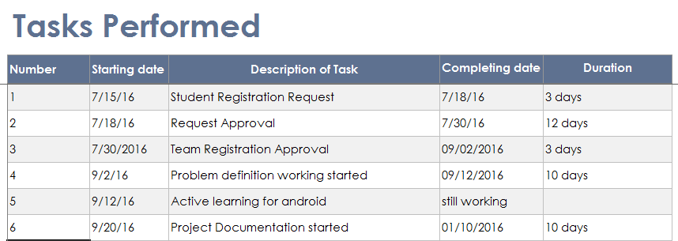

Figure 3.1.1 Project Scheduling Chart

**3.4 Software Process Model**

For mobile application development, teams are looking to introduce a lightweight development process like agile software development, which offers tremendous opportunities and value to build applications in short cycles.

Development organizations and teams that build mobile applications are challenged with their own unique set of complexities. Unlike traditional client-server and web-based software development, mobile developers are faced with very strict boundaries like memory, screen size, input devices, etc., short application lifecycles, and extreme usability requirements. That’s why mobile application developers should become quick in dealing with all of the variables in the development and deployment lifecycle.

Some restrictions with mobile application development are:

* Mobile has restrictions with the size of the applications.
* Application should be downloadable very fast.
* Update applications quickly and smoothly.
* Error free and fast.
* Seamlessly interact with the backend server as needed.

## **Scrum Definition**

Scrum is a framework within which people can address complex adaptive problems, while productively and creatively delivering products of the highest possible value.

Scrum is a process framework that has been used to manage complex product development since the early 1990s. Scrum is not a process or a technique for building products; rather, it is a framework within which you can employ various processes and techniques. Scrum makes clear the relative efficacy of your product management and development practices so that you can improve.

The Scrum framework consists of Scrum Teams and their associated roles, events, artefacts, and rules. Each component within the framework serves a specific purpose and is essential to Scrum’s success and usage.

The rules of Scrum bind together the events, roles, and artifacts, governing the relationships and interaction between them. The rules of Scrum are described throughout this tutorial.

Across the industry, there are misconceptions that Scrum means no documentation, scrum team consists of only developers, and so on. It is not entirely so.

**Scrum Process Framework**

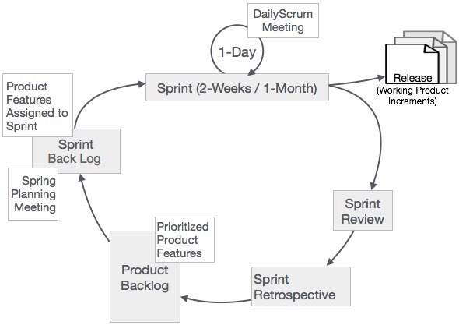

Fig: 3.4.1 Scrum Process Frame Work

In Scrum, the prescribed events are used to create regularity. All events are time-boxed events, such that every event has a maximum duration.

## **Sprint**

The heart of Scrum is a Sprint, a time-box of two weeks or one month during which a potentially releasable product increment is created. A new Sprint starts immediately after the conclusion of the previous Sprint. Sprints consist of the Sprint planning, daily scrums, the development work, the Sprint review, and the Sprint retrospective.

* In Sprint planning, the work to be performed in the Sprint is planned collaboratively by the Scrum Team.
* The Daily Scrum Meeting is a 15-minute time-boxed event for the Scrum Team to synchronize the activities and create a plan for that day.
* A Sprint Review is held at the end of the Sprint to inspect the Increment and make changes to the Product Backlog, if needed.
* The Sprint Retrospective occurs after the Sprint Review and prior to the next Sprint Planning. In this meeting, the Scrum Team is to inspect itself and create a plan for improvements to be enacted during the subsequent Sprint.

**CHAPTER 4: SYSTEM ANALYSIS**

**4.1 Literature Survey**

Book:

Android Wireless Application Development by Pearson Publications

Links:

developer.android.com

www.tutorialspoint.com/android/

We have used this link and book for our project development. The given book explains the detailed way to develop the application and system requirements.

The main help we got was from the sites that explained the step for development with visuals.

**4.2 Fact Finding**

The idea of making “Find Help” was obtained from the observations of day to day life style. We are students and we need notes and help regarding some topics of our subject .Students need help regarding study material, project. A Housewife need any help regarding any cooking dish, home décor ideas. Any person need help regarding health issues and many more. Upon asking we got to kwon that each and every person need help in anything.

We also saw the other applications which provides similar facilities but not exact as our idea. It was not that good and also not regarding to get different types of help at one place.

We also inquired people about it and they also gives us positive response towards our idea. Apart from that we asked them about their experience of current other applications somehow related with our application. From their experience we found that the system was not the correct one as it was time consuming, required paper work and manpower as well.

**4.3 Feasibility study**

**Feasibility Study key points: Mobile app marketing**

Feasibility study is an un-biased evaluation of an App idea, conducted for the purpose of determining whether the idea is viable and worth pursuing.

Major benefit of feasibility study is it helps in the guesswork (to a certain degree) out of the App launch. Hence avoiding any surprises during the course of App development/launch.

 The problems faced by the public are as follows:

1. People resist taking help from others.
2. People are not willing to help
3. They ask the wrong people for help.
4. They are not sure enough that this will help them or not.
5. They don’t know people whom they can approach.
6. Not more people know about the issue.
7. The issue doesn’t become viral.

Thus this drawback leads to the new android application development. We started working in this application due to the problems faced by the people. “HELP” is a word that everyone understands and this makes people desperate enough to ask for help. Helping people is indeed a blithe.

**4.4 System Requirement Engineering**

**a) Requirement Specification**

**i) Functional Requirements**

* + - A registration page for users to register
    - Users can log in using facebook accounts
    - Login page
    - Categories list

This list holds all the category help available in our application.

* + - Users can post their help.
    - Reply or comment on the post.
    - Notifications for the nearby users.
    - GPS will direct the application to send the user nearby.

**ii) Non-Functional Requirements**

1. **Security**

The application has the primary requirement to login into the system to do the next task. Hence this username and password of the user should be maintained properly and should not allow any unauthorized user to enter into the system.

The Find Help obtains the data for verification across the server. Hence the data transfer across the server should be secure. Also the data provided should be verified twice so that a user with incorrect detail should not be allowed to register into the system.

1. **Compatibility**

The Find Help should be able to run on the android phones as well as on other android enabled devices like tablet etc. It should also be developed in such a way that it should run on all the older versions of android.

1. **Portability**

The Find Help is an android based application running on mobile phones. Hence it should not take large amount of space such that it does not fit in the user’s device. The app should display the results rapidly minimizing the delay.

1. **Resource Utilization**

The Find Help has used various resources like personal database. This data are utilized to do the necessary verification for posting and accepting help.

**b) Requirement Definition**

This android application development started when help became helpless. Helpless people lose a lot when they cannot get help. Desperation and helplessness make people sad and to solve this problem we started the idea for the application.

Our help application works on the peoples help and the way they can be helped.

**c) Data Dictionary**

* + 1. Register_Master

Description: The Register_Master is the main table which include details about the registered user’s details.

|  |  |  |  |
| --- | --- | --- | --- |
| Sr. No | Field Name | Data Type | Constraint |
| 1 | Register_Id | INTEGER(11) | Primary Key |
| 2 | Register_Email | VARCHAR(100) |  |
| 3 | Rgister_Mobileno | INTEGER(10) |  |
| 4 | Register_Fullname | VARCHAR(100) |  |
| 5 | Register_Status | VARCHAR(250) |  |
| 6 | Register_Gender | VARCHAR(50) |  |
| 7 | Register_Createdate | DATE |  |
| 8 | Register_Profilepic | CLOB |  |
| 9 | Register_Fb_Id | VARCHAR(50) |  |

* + 1. Help_Master

Description: The Help_Master is used for accessing all the details regarding to help seeker.

|  |  |  |  |
| --- | --- | --- | --- |
| Sr. No | Field Name | Data Type | Constraint |
| 1 | Help_Id | INTEGER(11) | Primary Key |
| 2 | Register_Id | INTEGER(11) |  |
| 3 | Help_Name | VARCHAR(250) |  |
| 4 | Help_Discription | VARCHAR(250) |  |
| 5 | Help_Image | CLOB |  |
| 6 | Help_Location | VARCHAR(100) |  |
| 7 | Help_Gender | VARCHAR(50) |  |

* + 1. Helper_Master

Description: The Helper_Master is the table which include details about the

Help Munificent.

|  |  |  |  |
| --- | --- | --- | --- |
| Sr. No | Field Name | Data Type | Constraint |
| 1 | Register_Id | INTEGER(11) | Primary Key |
| 2 | Helper_Id | INTEGER(11) |  |
| 3 | Help_Id | INTEGER(11) |  |
| 4 | Help_Discription | VARCHAR(250) |  |
| 5 | Help_Location | VARCHAR(100) |  |
| 6 | Helper_Creator | VARCHAR(250) |  |

* + 1. Notification_Master

Description: The Notification_Master is the table which include details about the

Notification

|  |  |  |  |
| --- | --- | --- | --- |
| Sr. No | Field Name | Data Type | Constraint |
| 1 | Notification_Id | INTEGER(11) | Primary Key |
| 2 | Help_Id | INTEGER(11) |  |
| 3 | Register_Id | INTEGER(11) |  |

* + 1. Category_Master

Description: The Category_Master is the table which include details about the Category list.

|  |  |  |  |
| --- | --- | --- | --- |
| Sr. No | Field Name | Data Type | Constraint |
| 1 | Category_Id | INTEGER(11) | Primary Key |
| 2 | Category_Name | VARCHAR(250) |  |
| 3 | Category_CreateDate | DATE |  |
| 4 | Help_Gender | VARCHAR(50) |  |

* + 1. Subcategory_Master

Description: The Subcategory_Master is the table which include details about the Sub category.

|  |  |  |  |
| --- | --- | --- | --- |
| Sr. No | Field Name | Data Type | Constraint |
| 1 | Subcategory_Id | INTEGER(11) |  |
| 2 | Category_Id | INTEGER(11) |  |
| 3 | Subcategory_Name | VARCHAR(250) |  |
| 4 | Subcategory_CreateDate | DATE |  |

* + 1. Point_System

Description: The Point_System is the table which include details about Points of specific user.

|  |  |  |  |
| --- | --- | --- | --- |
| Sr. No | Field Name | Data Type | Constraint |
| 1 | Point_Id | INTEGER(11) | Primary Key |
| 2 | Help_User_Id | INTEGER(11) |  |
| 3 | Helper_User_Id | INTEGER(11) |  |
| 4 | Rating | INTEGER(11) |  |
| 5 | Created_Date | DATE |  |
| 6 | Comment | VARCHAR(250) |  |

**4.5 Unique Features of the Project**

**Badging System:** We are going to introduce a badging system that would encourage the helper to give more help. According to the satisfied seeker he/she will score the helper for his/her help.

The emotions will also define some scores.

😆 Excellent -15

😃 Happy – 10

😌 Satisfied – 5

☹ Disappointed – 0

After this we give badges when they cross every score huddle. This will make the application more interesting and attractive.

**CHAPTER 5: SYSTEM DESIGN**

**5.1 Use -Case Diagram**

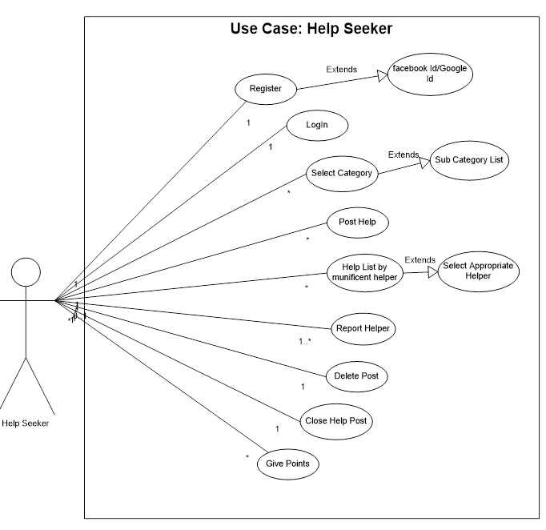

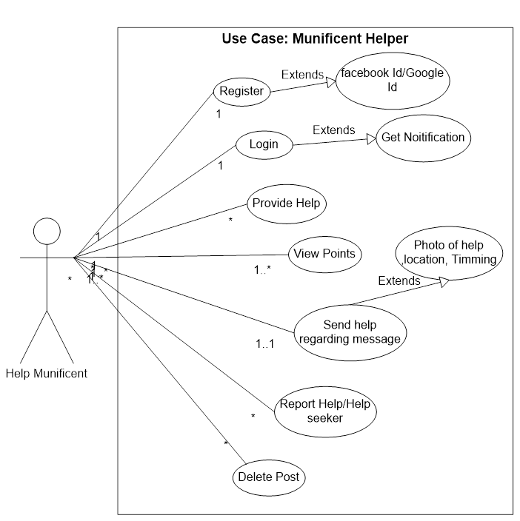

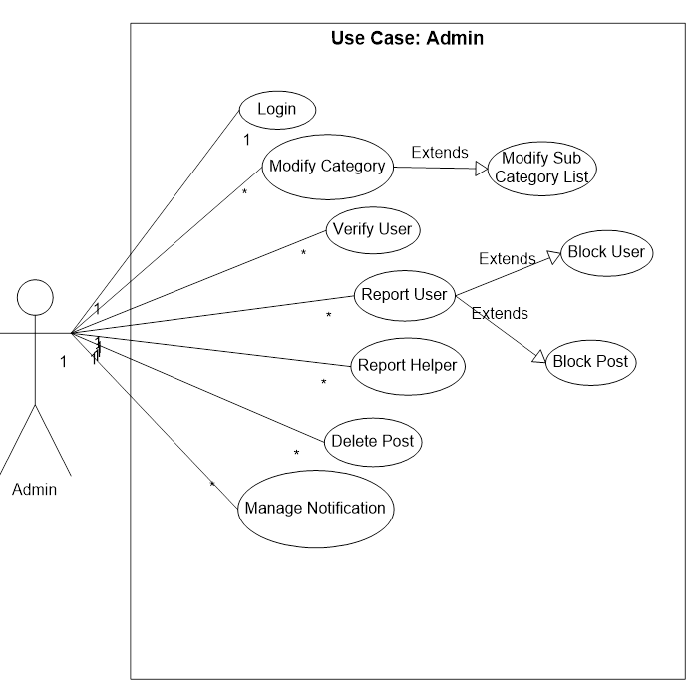

**5.2 Sequence Diagram**

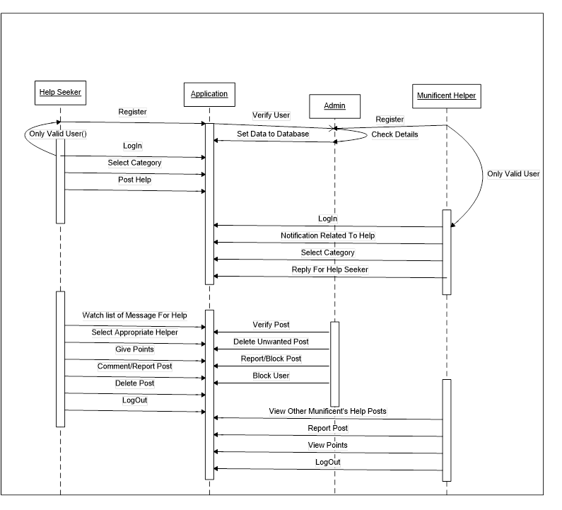

**5.3 Activity Diagram**

Register Activity:

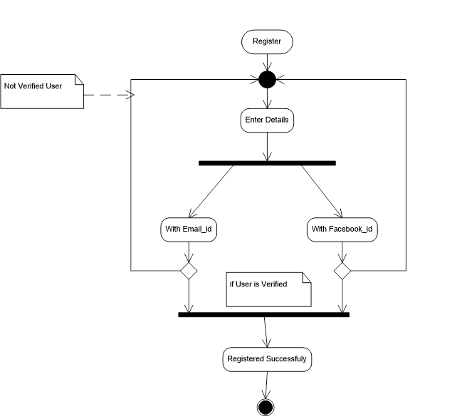

LogIn Activity:

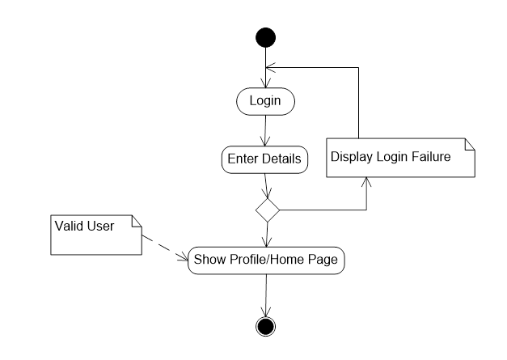

Help Activity:

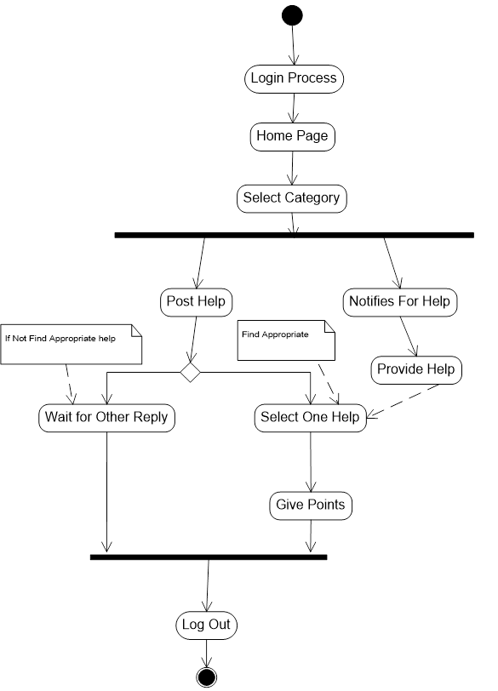

**5.4 State Diagram**

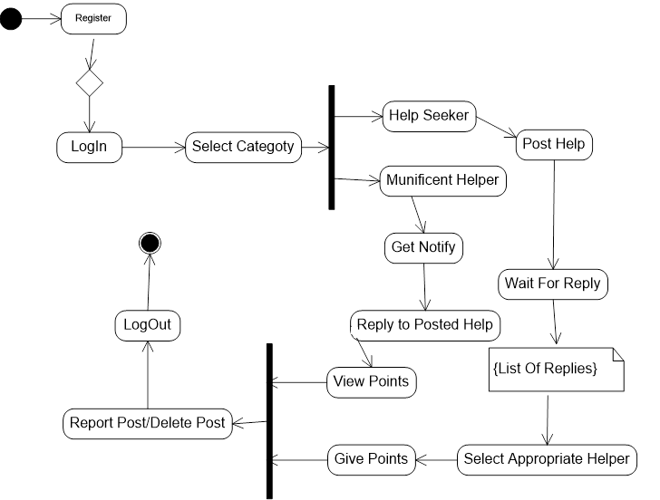

**5.5 E-R Diagram**

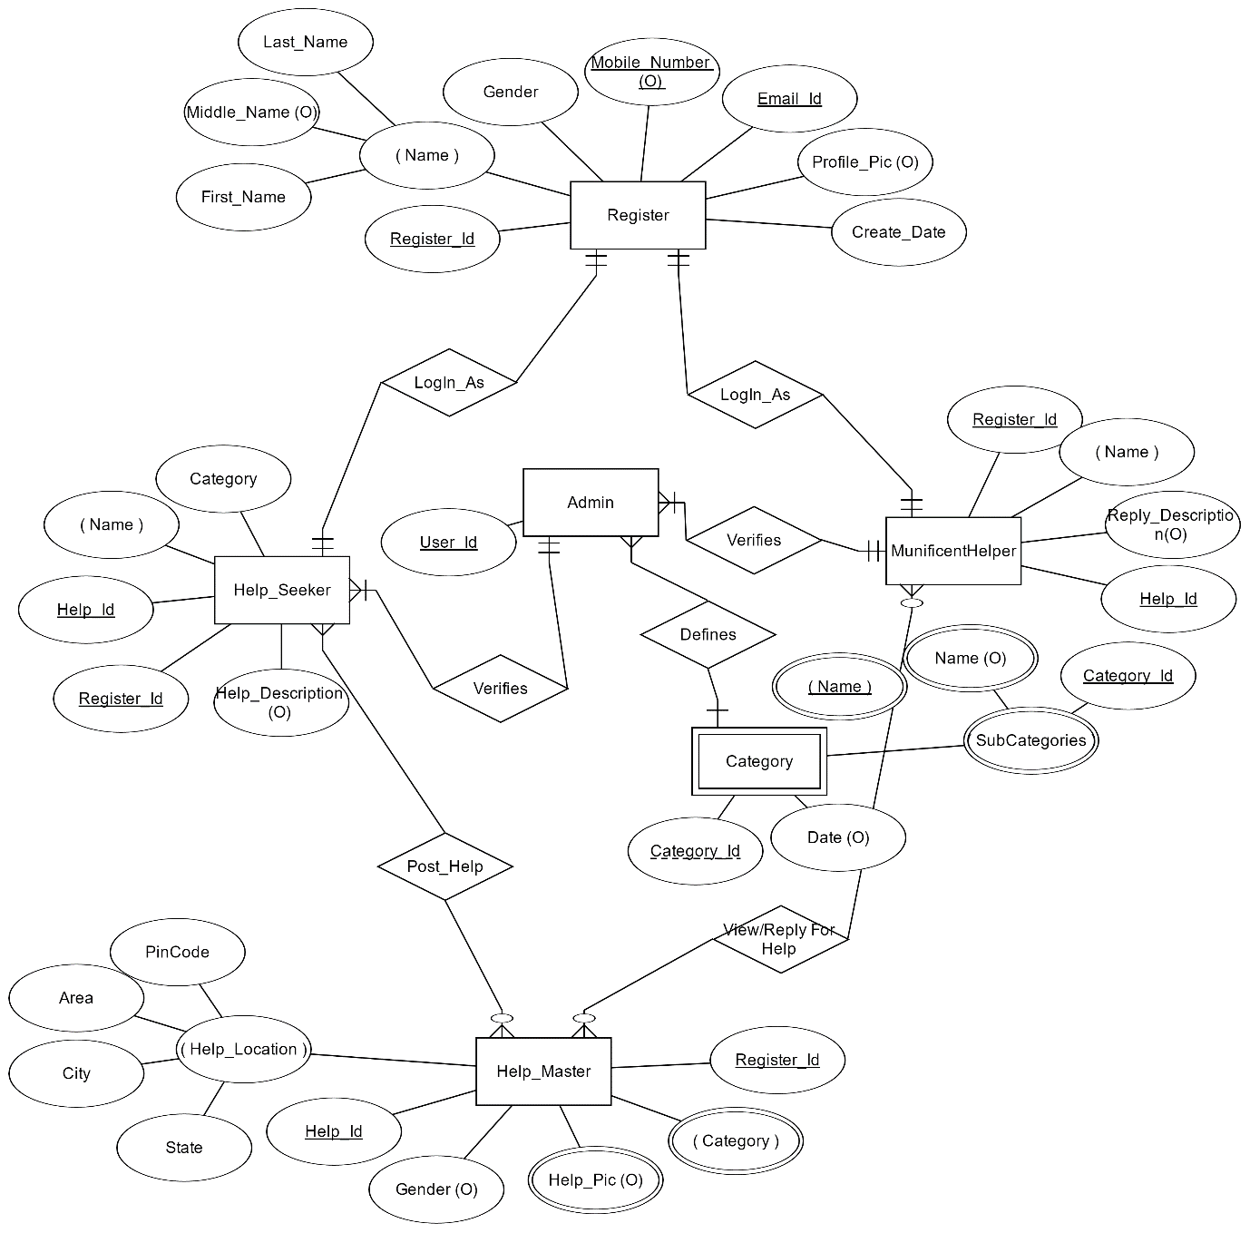

**5.6 Empathy Mapping Canvas**

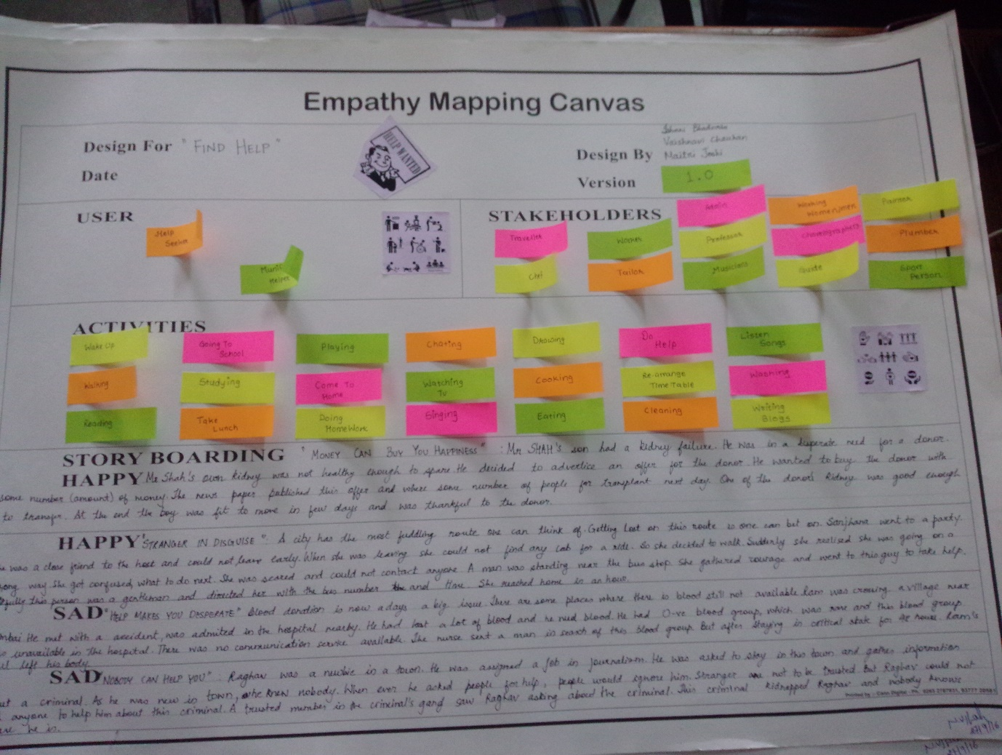

**5.7 Ideation Canvas**

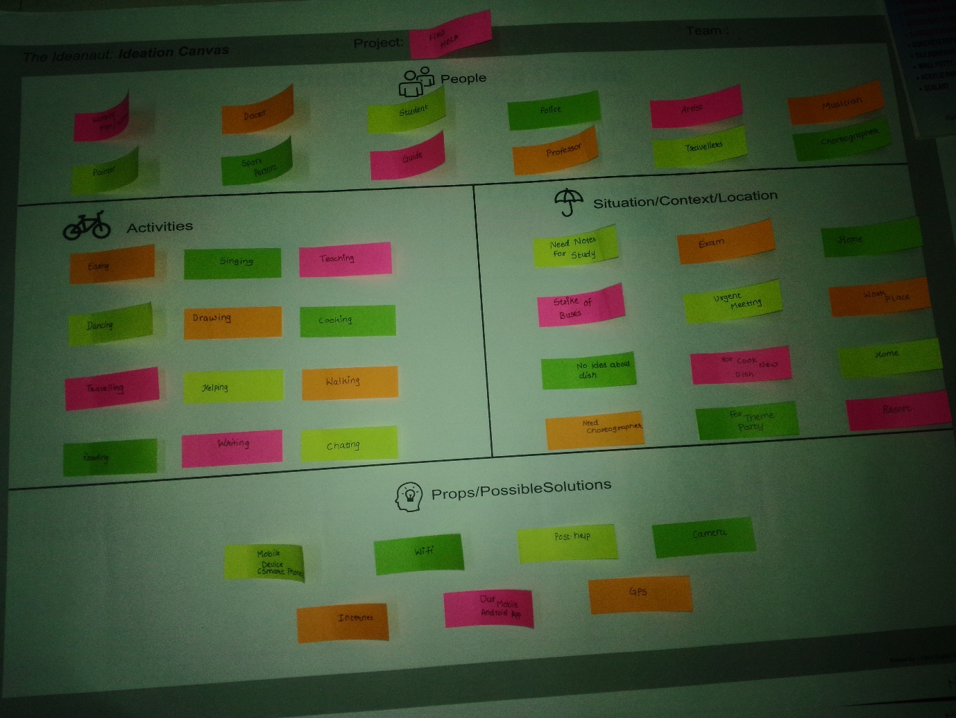

**5.7 Product Development Canvas**

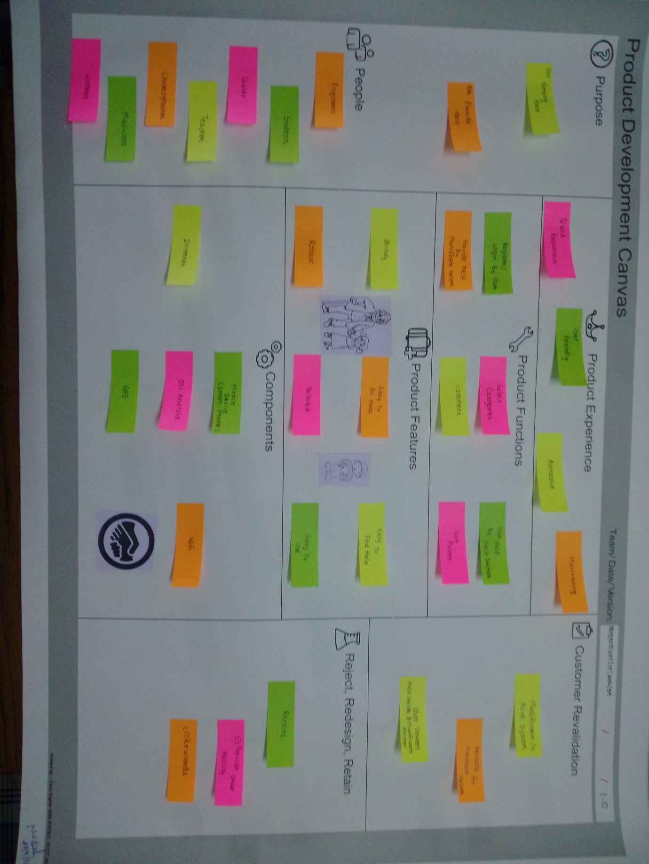

**5.8 AEIOU Summary Canvas**

